INSERT - DELETE

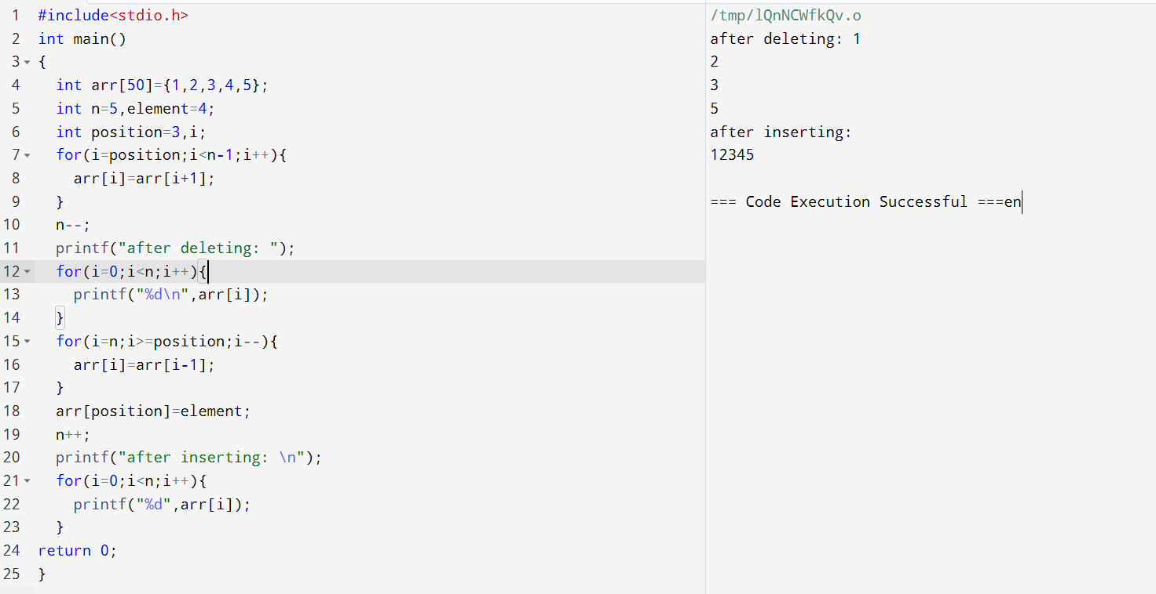

2. STACK IMPLEMENTATION USING ARRAY

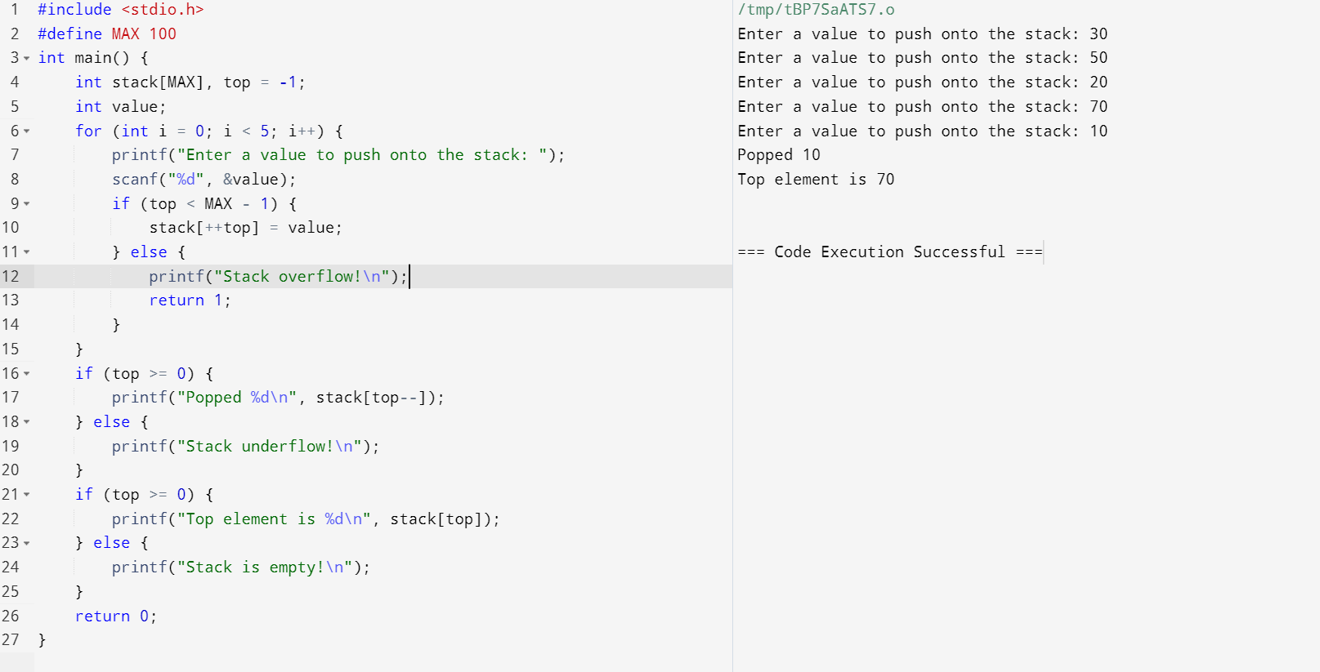

3.QUEUE IMPLEMENTATION USING ARRAY

